OPERATING SYSTEMS – PART 1
INTRODUCTION TO PROCESS

(Choose the correct option)
1. Applications have programs [instructions] and data that are not useful, as they remain passive and don't complete any tasks. OS converts them into process and makes it useful. Select the correct statements about a process.

A. Process is program under execution
B. Process can be termed as an active entity and programs can be termed as passive entity

a) Only A is correct b) Only B is correct
c) Both A and B are correct d) Both are incorrect.

(Virtualization of CPU)
2. Which of the following descriptions is closest and most accurate description for virtualization of CPU?
a) OS switches the CPU between different processes.
b) OS creates processes from the programs and data stored in disk.
c) OS runs multiple applications on a CPU and this creates the illusion that we are using multiple CPUs.
d) None of these.

(CPU Utilization)
3. The need for multiprogramming arises, in order to better utilize the CPU and increase the percentage of its utilization. Let's appreciate the increase in CPU utilization with the help of a problem.

Problem:
In a system using a single processor, there are six processes in the ready queue and each process will take seven seconds of CPU time to be complete its task. Assume that all the processes complete their tasks. Given the above information, find the percentage of CPU utilization in a minute?

a) 70% b) 30% c) 64% d) 60%

(How OS creates a process)
4. Following are the steps taken by OS to create a process, but they are written in jumbled up order.

1. OS completes few initial tasks related to I/O [Assume that OS has to run a program which takes an input of integer and print its multiplication table. In this case, tasks related to I/O will be to take input of integer and printing its multiplication table.]
2. OS allocates runtime stack to the process
3. OS loads the program and its static data in the memory
4. OS allocates heap memory to the process
5. OS gives process’s control to CPU

Select the correct order from the following options.
a) 3, 4, 2, 1, 5 b) 3, 2, 4, 1, 5 c) 3, 4, 1, 2, 5 d) 1, 2, 3, 4, 5

(View of Allocated Memory of Process)
5. Allocated memory of process has four parts in it: text, data heap and stack.
Alt Text


Match the parts of allocated memory with their most accurate composition.

Parts of Allocated Memory | What is stored in it?
1. text | a. Local variables, functions parameters and return values.
2. data | b. Compiled code
3. heap | c. Global and static data
4. stack | d. Dynamically allocated data

a) 1 - b, 2 - c, 3 - d, 4 – a b) 1 - a, 2 - b, 3 - c, 4 - d
c) 1 - b, 2 - d, 3 - c, 4 – a d) 1 - a, 2 - c, 3 - d, 4 - b

(Errors During Process Execution)
6. Let's assume that during process execution, the code keeps on spawning functions through recursive calls.

At one stage, the stack will meet the heap. This will result in P error.

In another scenario, if the stack and heap have met and there is no memory to give. At this stage, if the code requests heap memory, then it will result in Q error.

Identify the correct description of P and Q.
a) P = Memory Insufficient Error, Q = Stack Overflow Error
b) P = Illegal Memory Referencing Error, Q = Memory Insufficient Error
c) P = Stack Overflow Error, Q = Memory Insufficient Error
d) P = Memory Insufficient Error, Q = Illegal Memory Referencing Error

(Process Control Block)
7. Which is the correct description about Process Control Block?
a) Process type variable b) Per process data structure
c) A block of space in disk for each application d) A block in memory for each application

(Order of Instruction Execution)
8. The steps, which OS follows to execute the instructions of a process, are written in random order.

1. Increment the Program counter
2. Fetch the instruction from the address in the Program Counter
3. Execute the instruction

Select the correct order these steps.

a) 2, 3, 1 b) 3, 1, 2 c) 2, 1, 3 d) 1, 2, 3

(State Transitions)
9. Consider the following statements about process state transitions for a system.

I. A running process can move to ready state.
II. A ready process can move to running state.
III. A blocked process can move to running state.
IV. A blocked process can move to ready state.

Which of the above statements are TRUE ?
a) I, II, and III only b) II and III only
c) I, II, and IV only d) I, II, III and IV only

(State after I/O instructions)
10. The state of a process after it encounters an I/O instruction is?
a) Ready b) Blocked c) Idle d) Running

(Ready State)
11. Process is in a ready state _______ .
a) when process is scheduled to run after some execution
b) when process is unable to run until some task has been completed
c) when process is using the CPU
d) None of these

(Choose the correct option)
12. The processes that are residing in main memory and are ready and waiting to execute are kept on a list called _____________
a) job queue b) ready queue
c) execution queue d) process queue

(Process Transitions)
13. In the following process state transition diagram for a uniprocessor system, assume that there are always some processes in the ready state: Now consider the following statements:

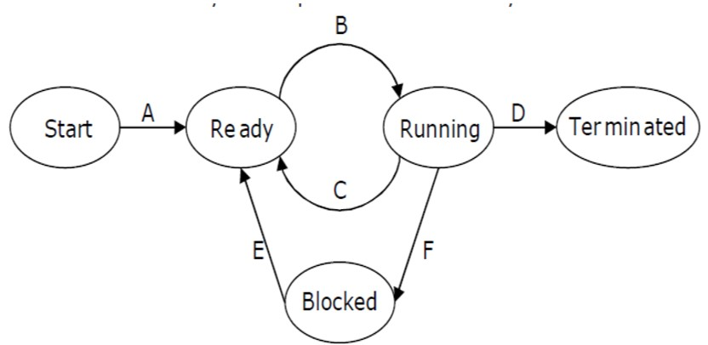

I. If a process makes a transition D, it would result in another process making transition A immediately.
II. A process P2 in blocked state can make transition E while another process P1 is in running state.
III. The process queues involved in transition A are job queue and ready queue.
IV. The process queues involved in transition E are job queue and waiting queue.

Which of the above statements are TRUE?
a) I and II b) I and III c) II and III d) II and IV

(Choose the correct option)
14. Match the following:
List 1 | List 2
A. Moves suspended process to secondary storage | I. Short term scheduler
B. Loads the process into memory for execution | II. Long term scheduler
C. Moves one of the processes to running state | III. Medium Term Scheduler

a) A - I, B - II, C – III b) A - II, B - I, C - III
c) A - III, B - II, C – I d) A - I, B - III, C - II

(Saving and Restoring States)
15. If you are performing a "state save" on the current process and a "state restore" on a different process, while switching the CPU from one process to another is called ________
a) State Switch b) Context Switch c) Process State Change d) PCB Change

(Context Switching)
16. Select the correct statements about context switching.

A. Context switching gives you the ability to do multiprogramming
B. Context switching only happens when the current process has to do I/O operation.

a) Only A b) Only B
c) Both are correct d) Neither A nor B is correct

(Time Out Request)
17. In the following diagram, what conclusions can you draw from the time-out request and subsequent execution of context switching instructions indicate about process management?

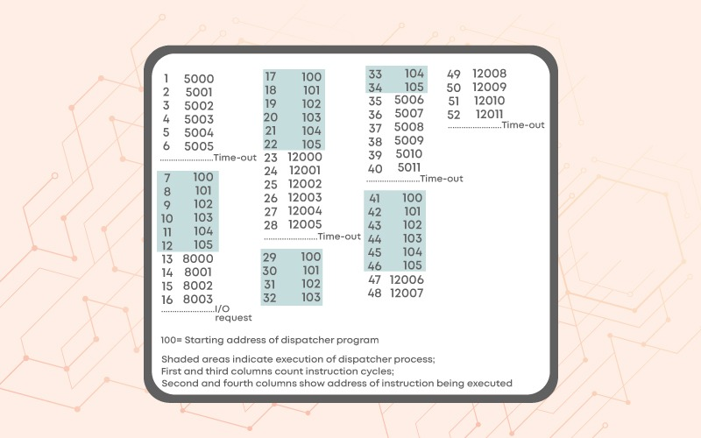

(Child Process Creation)
18. Which of the following statements are correct, if a parent process creates a new child process?

i. Both the processes have ppid associated with them.
ii. Both parent process and child process have different process ids.

a) Only i b) Only ii
c) Both i and ii d) None of these

(Process Termination)
19. We have already discussed the reasons for which a process may get terminated. Now, think and select which of the following is/ are legitimate reasons due to which a process may terminate one of its child processes?
a) The child process is taking more resources than allocated.
b) The task assigned to the child process is no longer required.
c) The parent process is terminating, and the OS does not allow a child to continue if its parent exits
d) All the above.

(Orphan Process)
20. Explain Orphan Process.

(Zombie Process)
21. Zombie Process

(Commands Exploration)
22. As you have tried the commands explained in the lecture video on the terminal and you have explored the man pages of various commands, let us try out a few more commands. In this question, our focus will be on grep command. Please read about grep on Linux man pages.

Before trying these commands, create the following files in the home folder by using using following command: cat > cnfile.txt

After writing this command, the prompt will not be returned back to you, after pressing enter key. So, whatever you will write on the terminal, it will become the contents of your file: cnfile.txt. So, let’s write “linux is great os. linux is opensource. linux is free os.” and press Ctrl + C to terminate the process of writing to this file.

Now, you have to run the following commands in Bracket - 1 and match them to their appropriate outputs in Bracket – 2

Bracket - 1 | Bracket - 2
1. grep -c "linux" cnfile.txt | a. Displays only the matched pattern
2. grep -l "linux" * | b. Checks the complete words in a file
3. grep -w "linux" cnfile.txt | c. Displays the file names that matches the pattern
4. grep -o "linux" cnfile.txt | d. Displays the count of number of matches

a) 1 - a, 2 - c, 3 - b, 4 – d b) 1 - d, 2 - c, 3 - b, 4 - a
c) 1 - d, 2 - b, 3 - c, 4 – a d) 1 - a, 2 - b, 3 - c, 4 - d

**********

